1. WAVELENGTH:-

import java.util.Scanner;

public class Main

{

public static void main(String[] args)

{

double n;

Scanner x=new Scanner(System.in);

n=x.nextDouble();

if(n>=380&&n<450)

{

System.out.println("the color is violet");

}

else if(n>=450&&n<495)

{

System.out.println("the color is blue");

}

else if(n>=495&&n<570)

{

System.out.println("the color is green");

}

else if(n>=570&&n<590)

{

System.out.println("the color is yellow");

}

else if(n>=590&&n<620)

{

System.out.println("the color is orange");

}

else if(n>=620&&n<750)

{

System.out.println("the color is red");

}

else

System.out.println("the entered wavelength is not a part of the visible spectrum");

}

}

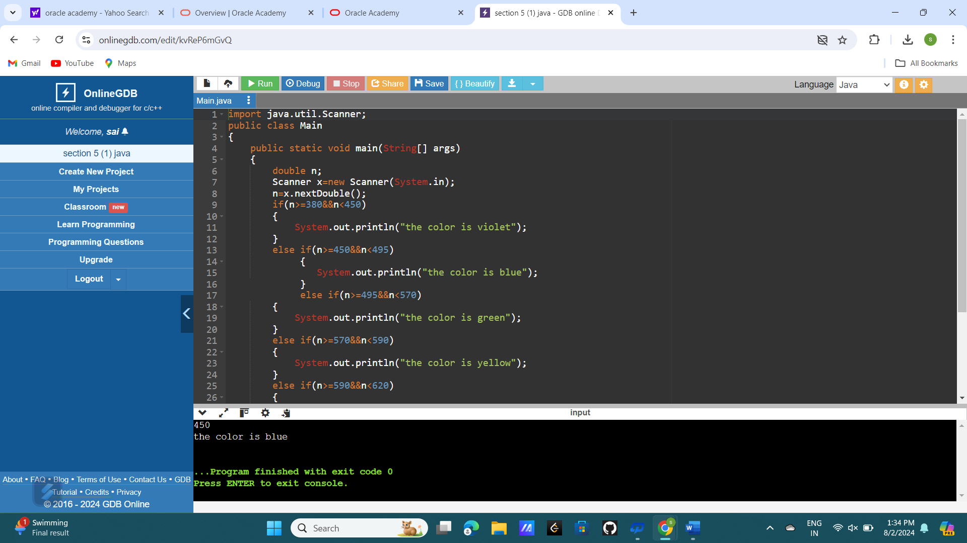

1. TRAFFIC SIGNAL IF CONDITION:-

import java.util.Scanner;

public class Main

{

public static void main(String[] args)

{

int n,red=1,yellow=3,green=2;

Scanner x=new Scanner(System.in);

n=x.nextInt();

if(n==1)

{

System.out.println("Next Traffic Light is green");

}

else if(n==3)

{

System.out.println("Next Traffic Light is red");

}

else if(n==2)

{

System.out.println("the next color is yellow");

}

else

System.out.println("invalid color");

}

}

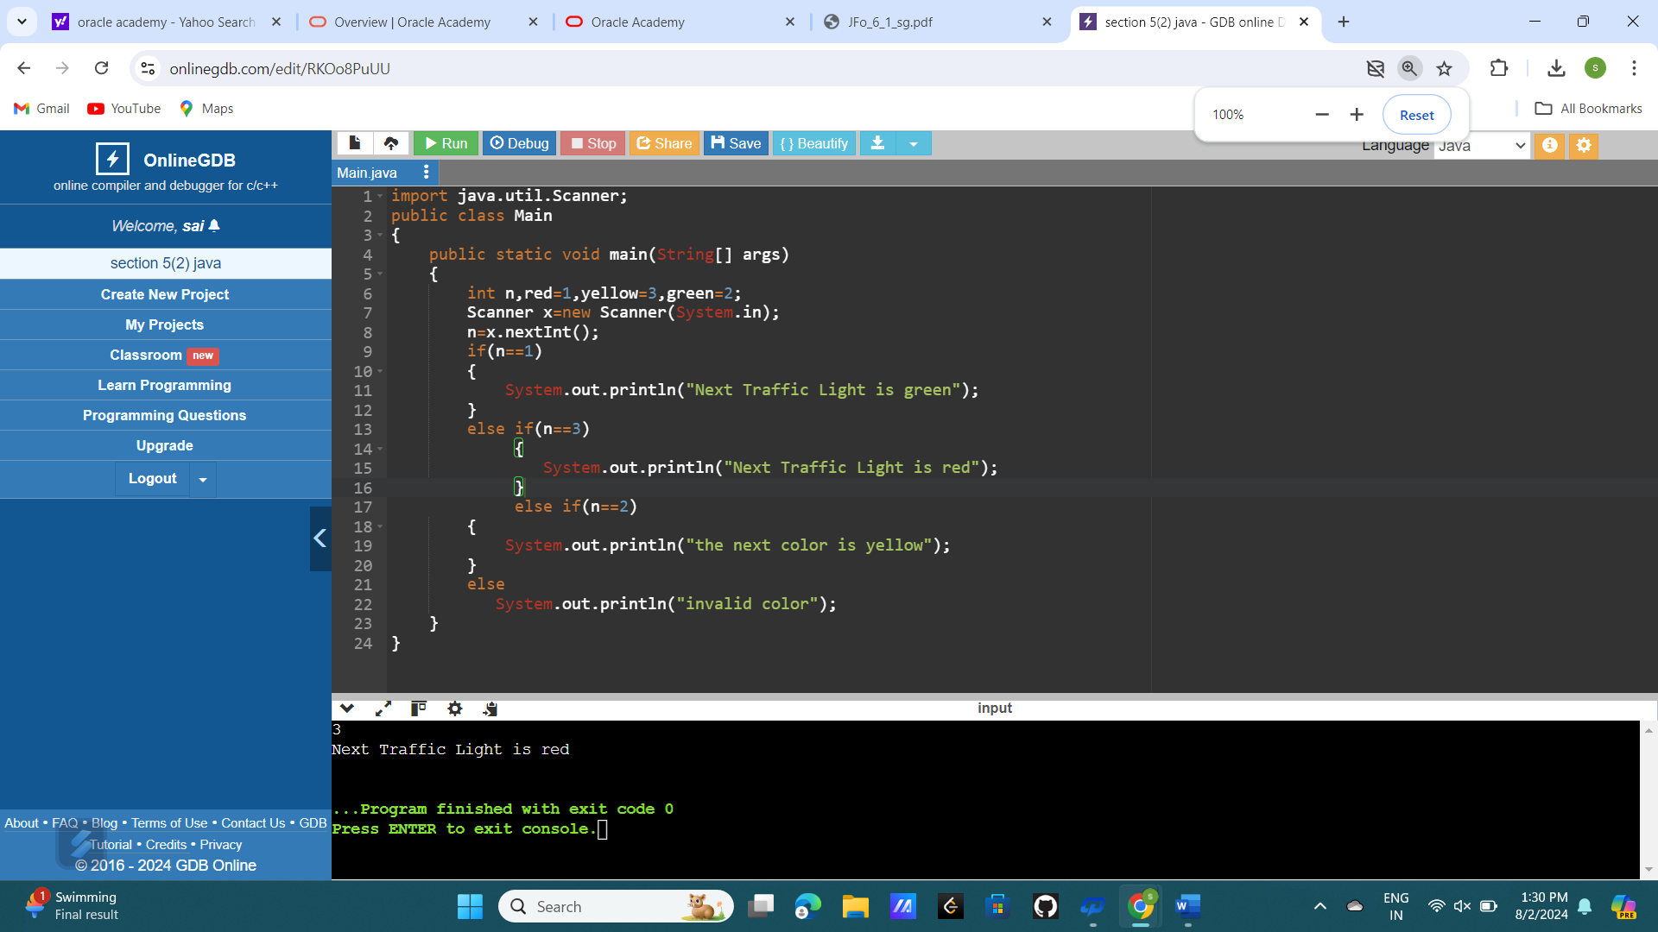

1. TRAFFIC SIGNAL SWITCH CONDITION:-

import java.util.Scanner;

public class Main

{

public static void main(String[] args)

{

int n,red=1,yellow=3,green=2;

Scanner x=new Scanner(System.in);

n=x.nextInt();

switch(n)

{

case 1:

System.out.println("Next Traffic Light is green");

break;

case 3:

System.out.println("Next Traffic Light is red");

break;

case 2:

System.out.println("the next color is yellow");

break;

default:System.out.println("invalid color");

}

}

}

